*Copy and paste into email invite, change the events details to yours and send to friends*

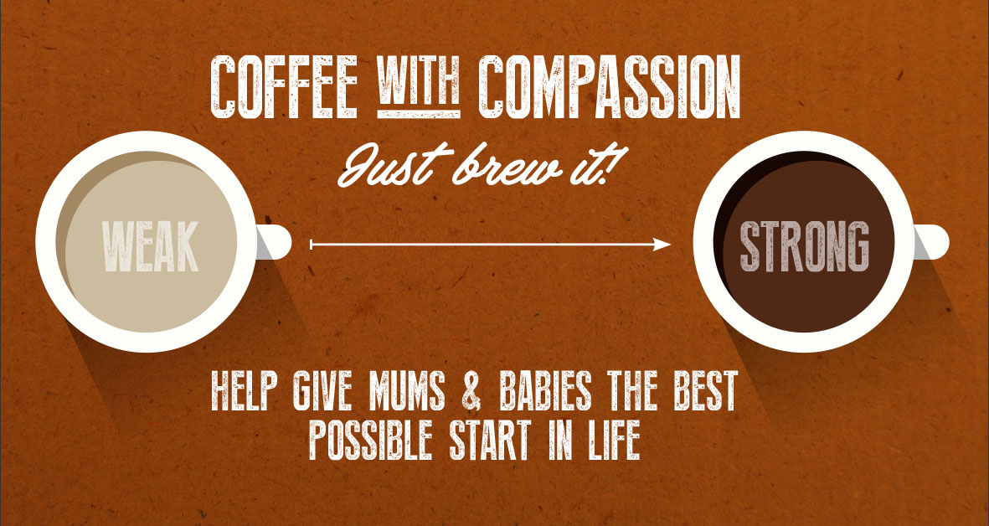
Hi <everyone>,
I’m hosting a Coffee with Compassion event and would love it if you’d join me! We’ll be having tea, coffee and cake whilst raising money for Compassion’s Child Survival Programme – something that’s very close to my heart.
Let me know if you could join me on <date> at <time>, at <address>.
I’d love to see you on the day. If you could RSVP by <date> I would appreciate it.
Hope to see you then!
<Your name>
PS. If you want to find out about the Child Survival Programme, here’s the link to more info. www.compassionuk.org/give/child-survival-programme/

